# Installing R[1]

## Prerequisites

* Download and install R (version 3.5.2).   
  Windows: <https://cran.r-project.org/bin/windows/base/R-3.5.2-win.exe>
* For other operating system options go to <https://cran.r-project.org/>  
  Once the installation file is downloaded, start the installer and use the default settings to install R on your machine.
* Download and install RStudio (version 1.1.463). Windows:  
  <https://download1.rstudio.org/RStudio-1.1.463.exe>  
  For other operating system options go to <https://www.rstudio.com/products/rstudio/download/>  
  Once the installation file is downloaded, start the installer and use the default settings to install RStudio on your machine.
* Open RStudio. In the bottom-right pane click on **Packages** tab, and then click the **Install** button. In the dialog window that appears type "Rcpp" in the middle text box. Click the **Install** button. Repeat the process and install the “rmarkdown” package. Use the following screenshot for reference.

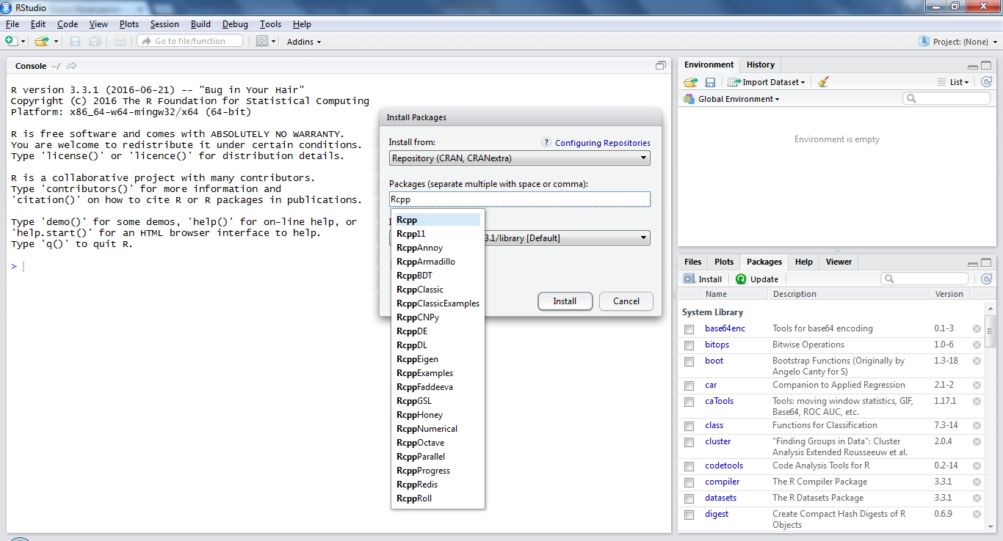

1. Prepared over the years by Pavel Teterin, Xiaohu Guo, and Tim Cao.